PACER Access for Interns/Externs

Overview:
- Intern/Extern must register for PACER account
- Once registered, HR will ask PACER to make the account exempt from fees

Procedure Descriptions/Steps:

Pacer.uscourts.gov

- Select Register for an Account tab
- Using the dropdown menu, select PACER – Case Search Only

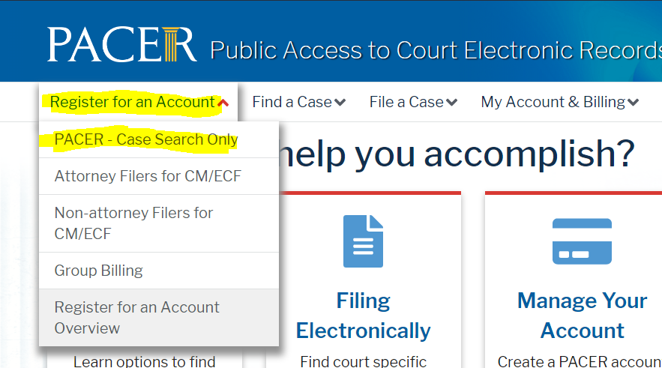

- Select Register for a PACER account button located in the bottom, left corner

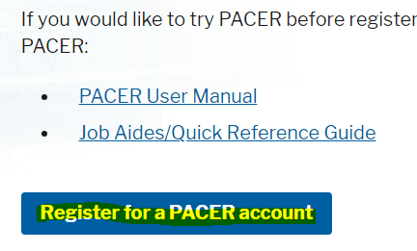

- Enter the required account information
- In the User Type field, select Individual
- Select the Next button

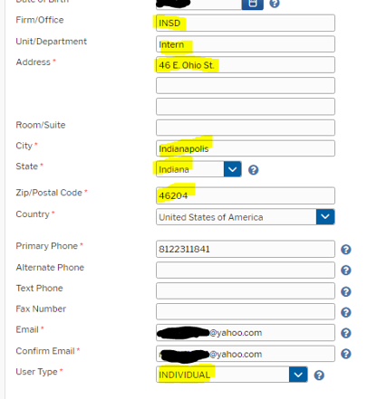

When prompted, create a username and password
- Enter a username (at least 8 characters, but no more than 40), or select Generate Username button
- Enter a password (8-45 characters, one lowercase letter, one uppercase letter and one special character)

- Select two Security Questions and enter appropriate Answers
- Select the Next button

When prompted for payment information, do NOT enter any payment information
- Select the Next button

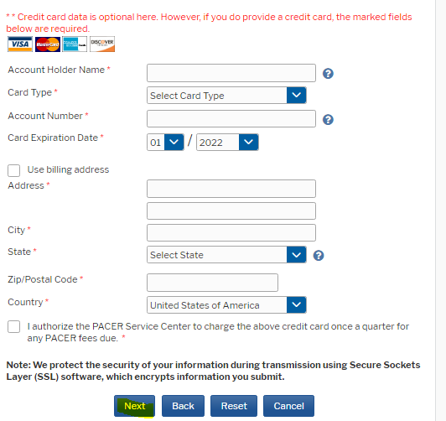
NOTE: Your account will be exempt from paying fees during your time with the Court.

When prompted for Acknowledgment of Policies and Procedures
- Review the Policies and Procedures
- Click in the empty box acknowledging box
- Select the Submit button

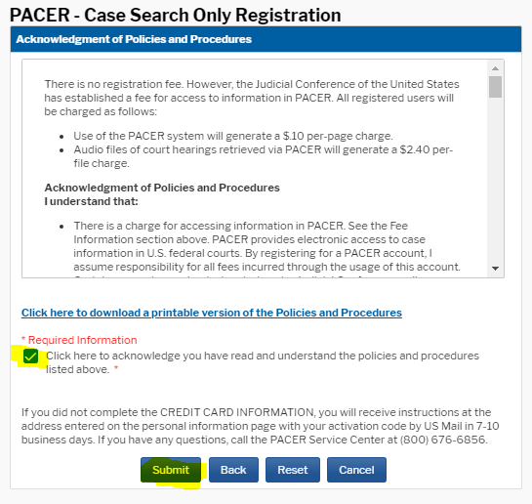
When prompted with the Thank you for registering screen
- Select the Done button
